Figure 1-2
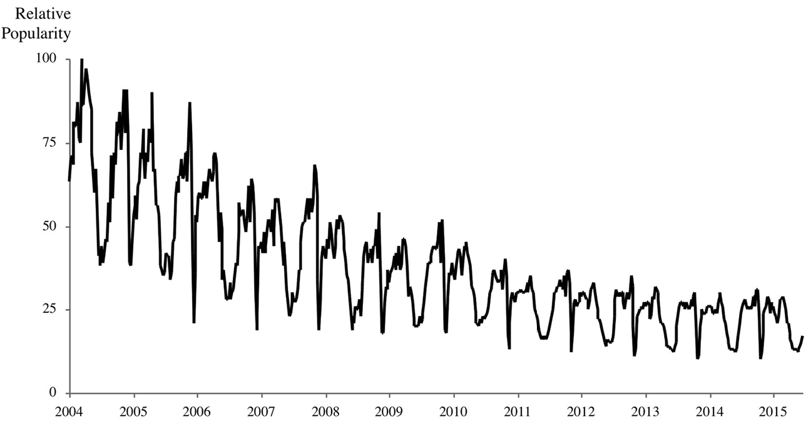
Figure 1-2. Google searches for “globalization” have been declining for a decade.
Source: Google Trends (2015). “Interest over Time: Globalization.” Retrieved from www.google.com/trends.
- A line graph depicting the Relative Popularity of searches for the term globalization. The horizontal x-axis shows the years 2004 to 2015, and Relative Popularity appears on the vertical y-axis, ranging from 0-100. The line has many peaks and valleys, but trends steadily downwards, with high points being around 100 in 2004 to around 30 in 2015, and low points being around 40 in 2004 and 20 in 2015.

Figure 2-8
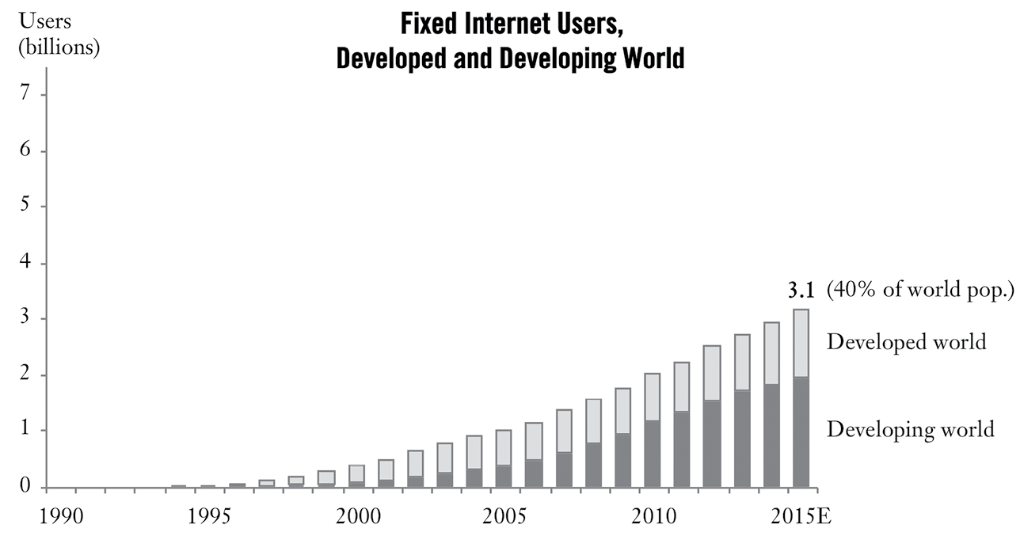
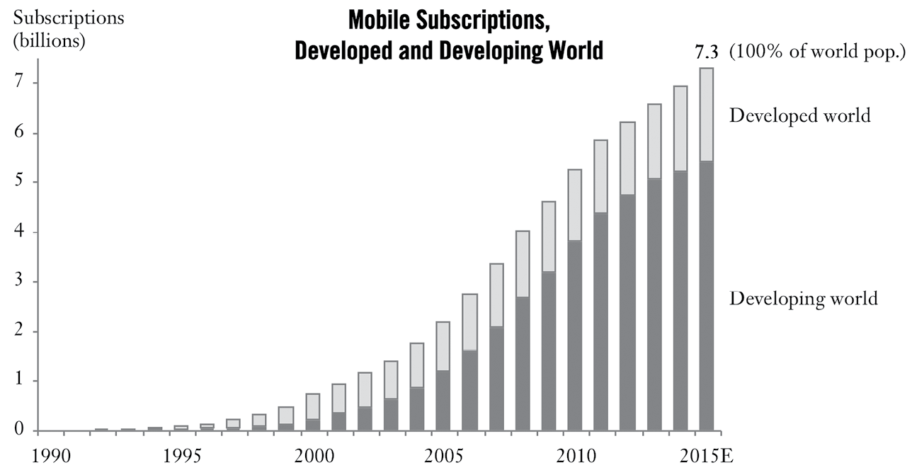
Figure 2-8. In just 20 years, almost all humanity has been connected, by voice or data.
Source: World Bank Databank (2015). World Development Indicators. Retrieved from data.worldbank.org.
- Description (Graph 1): A bar chart titled "Fixed Internet Users, Developed and Developing World". The vertical y-axis shows number of users in billions, numbered from 0-7; the horizontal x-axis shows years, from 1990-2015. No bars appear until 1994, then growth steadily increases until 2015. Users reach 1 billion around 2005, 2 billion around 2010, and 3.1 billion, or 40% of the world’s population, in 2015. From 1994 to 2006, the number of users in the developing world is less than the number of users in the developed world. From 2007-2009, the numbers are approximately equal. From 2010 to 2015, The number of users in the developed world is less than the number of users in the developing world.
- Description (Graph 2): Bar graph titled "Mobile Subscriptions, Developed and Developing World". The X and Y axes are the same as on the previous graph: users, in billions, and time, from 1990-2015. Reaches 1 billion in 2001, 2 billion in 2004, 3 billion in 2006, 4 billion in 2008, 5 billion in 2010, 6 billion in 2012, and 7 billion in 2014. In 2015, the graph shows that there are 7.3 billion mobile subscriptions, and labels this as 100% of world population. The number of users in the developed world vs the developing world changes at the same rate as in the previous graph.

Figure 2-9
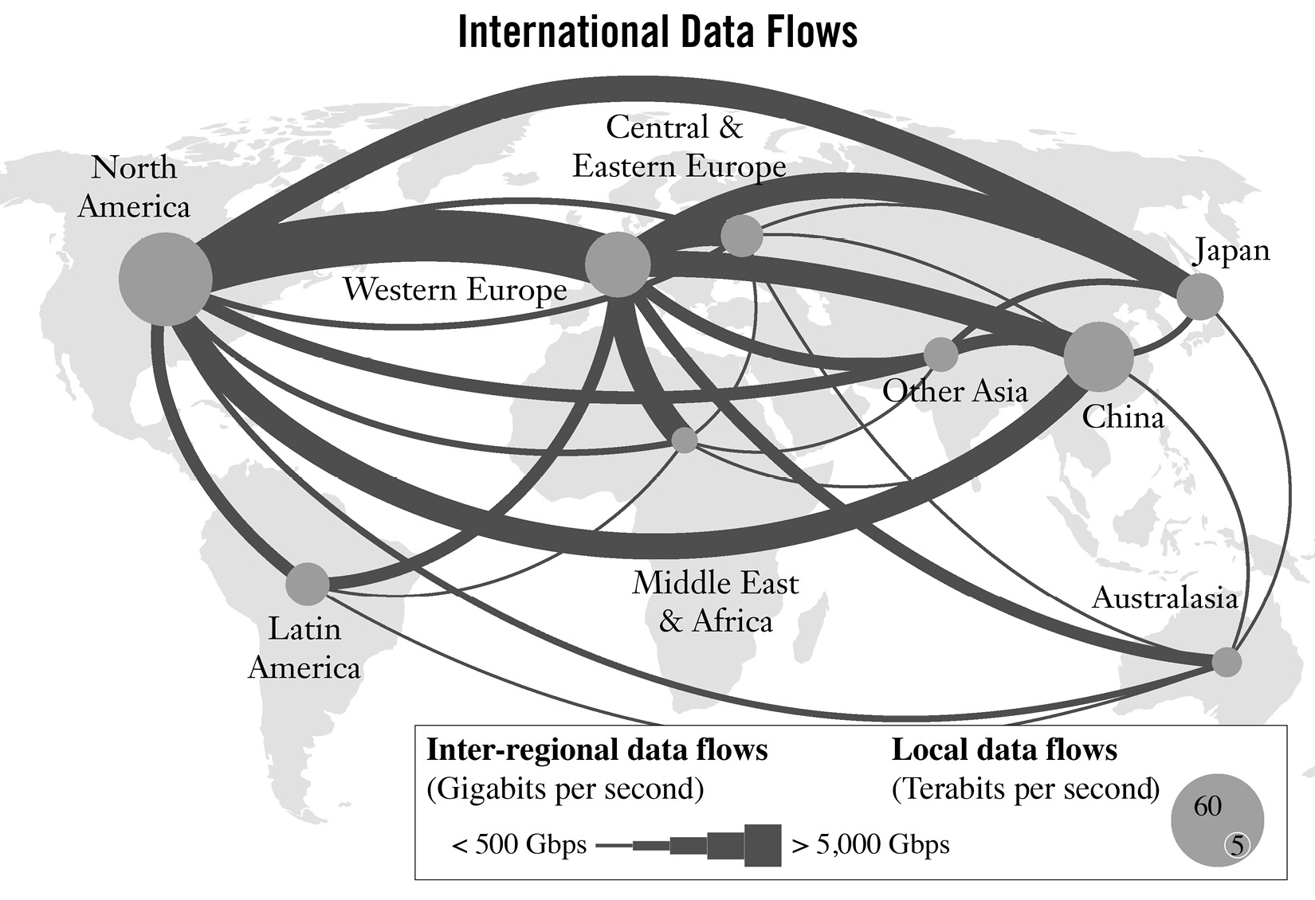
Figure 2-9. Data now flows thickly between all continents.
Source: James Manyika, Jacques Bughin, et al. (2014). Global Flows in a Digital Age. New York: McKinsey Global Institute; Cisco (2015). Visual Networking Index. Retrieved from www.cisco.com; plus authors’ analysis.
- Description: Diagram titled "International Data Flows". It shows a map of the world with lines of varying thickness connecting continents, which are labeled by dots of varying size. A legend at the bottom of the diagram explains: Inter-regional data flows, measured in Gigabits per second (GBPS), are represented by the lines. The thinnest lines are used for data flows of less than 500 GBPS, while the thickest ones are for data flows of greater than 5000 GBPS. The circle sizes represent Local data flows in Terabits per second (TBPS); the largest circle represents 60 TBPS, while the smallest represents 5 TBPS. The thickest line appears between North America and Western Europe. The next thickest between North America and Japan; North America and China; Western Europe and Japan; Western Europe and China; and Western Europe and Middle East/Africa. The largest local data flows circles appear on North America, followed by Western Europe and China. Smaller circles appear on Latin America, Central/Eastern Europe, and Japan. The smallest appear on Other Asia, Australasia, and the Middle East/Africa.

Figure 4-4
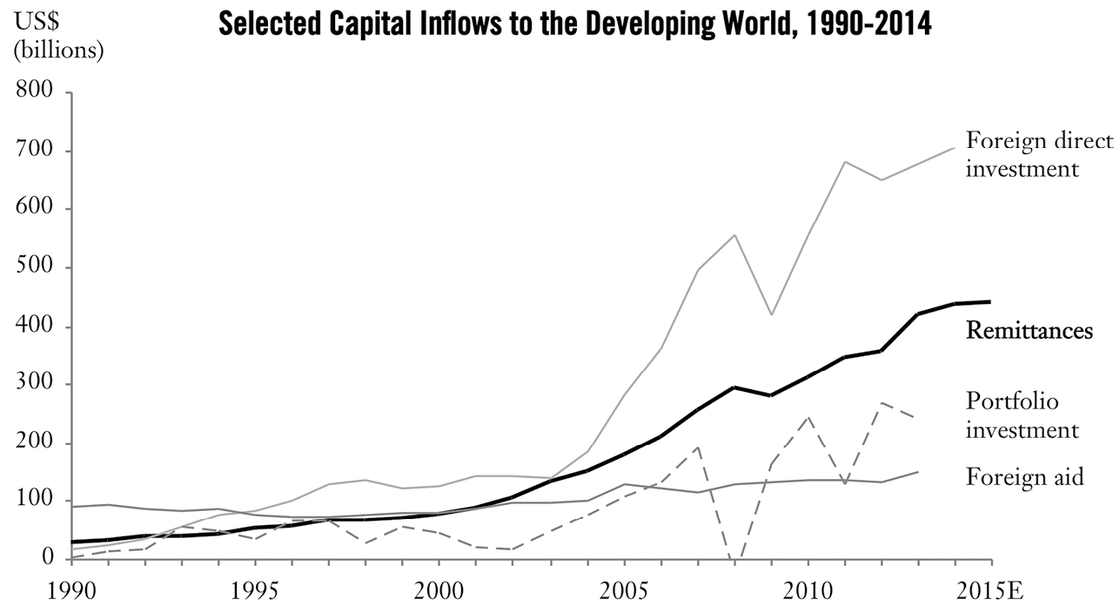
Figure 4-4. Remittance flows are larger than foreign aid and more stable than foreign investment.
Source: World Bank Databank (2015). World Development Indicators. Retrieved from data.worldbank.org; Remittance estimates taken from World Bank (2015, 13 April). Migration and Development Brief 24.
- Description: Line chart titled "Selected Capital Inflows to the Developing World, 1990-2014". The vertical y-axis shows money, in USD billions, ranging from 0 to 800. The Horizontal x-axis represents time, from 1990-2015. There are four lines: one for Foreign direct investment, which shows gradual growth until 2003, when it begins to climb more quickly. Between 1990 and 2003, foreign direct investment grew from just above zero to 150. From 2003 to 2007, it grew from 150 to 550. In 2008, it dropped to 400, then increases to 700 by 2015. The second line shows Remittances. It shows slow growth, from just above zero to 100 between 1990 and 2000, then grows more quickly, reaching 400 by 2015. The third line shows portfolio investment. Between 1990 and 2002, it trends up and down between 0 and 100, then grows to 200 by 2007. It then dips to zero, and then grows to over 200 by 2010. It drops to 150 in 2011, then grows to nearly 300 by 2015. The last line shows Foreign aid, which remains generally steady for the whole time period, remaining just below 100 from 1990 to 2004; from 2005 to 2015, it shows slow growth, increasing to almost 200 by 2015.

Figure 4-5
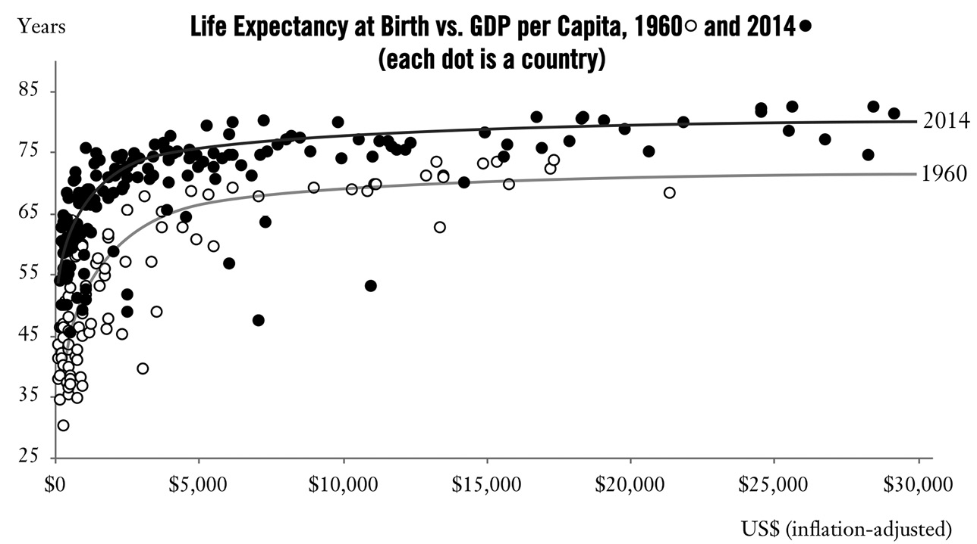
Figure 4-5. The spread of new ideas and technology means that at every level of income, children born today are living longer.
Source: World Bank Databank (2015). World Development Indicators. Retrieved from data.worldbank.org; adapted, with the authors’ gratitude for his generous engagement on this topic, from Angus Deaton (2013). The Great Escape: Health, Wealth, and the Origins of Inequality. Princeton, NJ: Princeton University Press.
- Description: Dot graph titled "Life Expectancy at Birth vs. GDP per Capita, 1960 and 2014". The vertical y-axis shows years, from 25 to 85. The horizontal x-axis shows USD, from 0 to 30,000. Dots represent countries; black dots represent data from 2014 while white dots represent data from 1960. Graph data is described in text.
    - Description from text: See Figure 4-5, which graphs life expectancy at birth against GDP per capita. Named the Preston curve after the economist who first drew it in 1975, the graph shows that as people’s incomes improve, their life expectancy moves up along a curve: faster gains at lower income levels, more modest gains after that. But over time, the entire curve shifts upwards, so that at every level of income, life expectancy is higher today than in 1960.

Figure 4-6
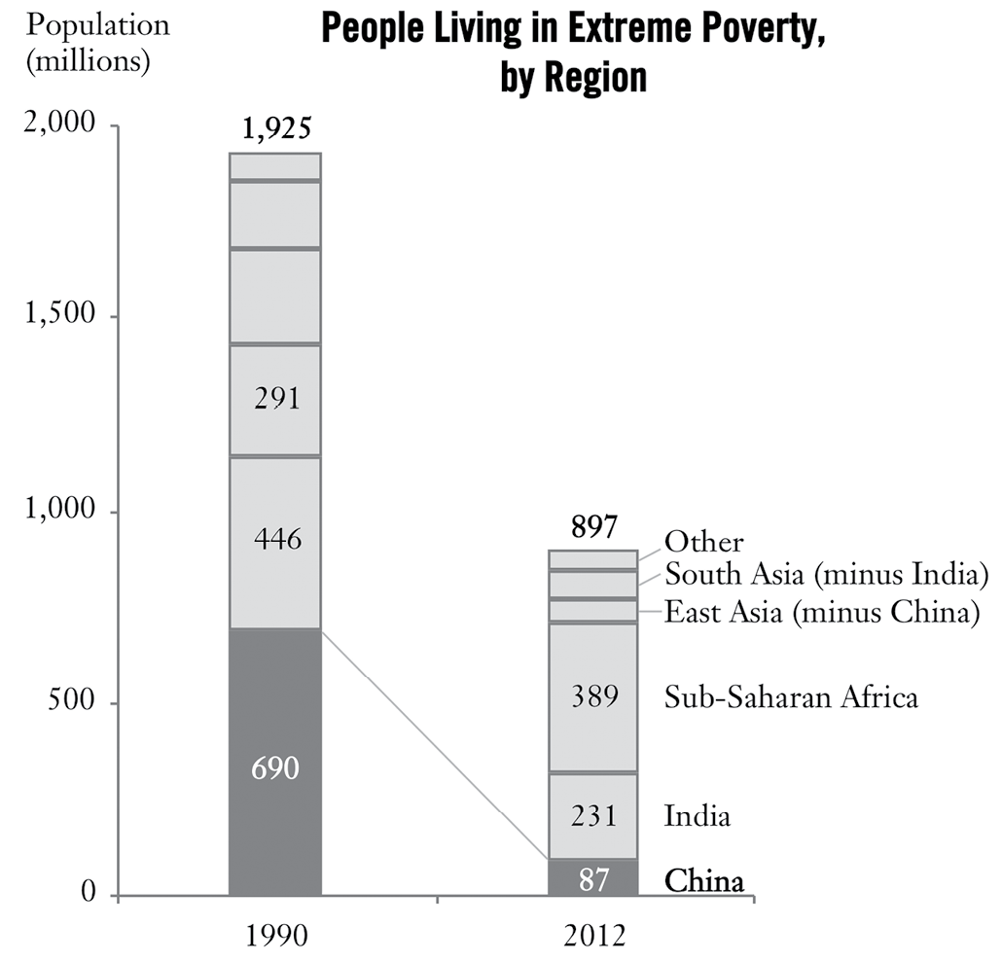
Figure 4-6. The fall in extreme poverty has taken place mainly in China.
Source: World Bank PovcalNet (2015). “Regional Aggregation Using 2011 PPP and $1.90/Day Poverty Line.” Retrieved from iresearch.worldbank.org/PovcalNet/index.htm?1.

- Description: Bar graph titled "People Living in Extreme Poverty, by Region". The vertical y-axis shows population, in millions, ranging from 0 to 2,000. The horizontal x-axis shows two dates: 1990 and 2012. The number of people living in poverty in China dropped from 690 million to 87 million; the number in India dropped from 446 million to 231 million; the number in Sub-Saharan increased, from 291 million to 389 million. East Asia (minus China) dropped from approximately 300 million to around 50 million. South Asia (minus India) dropped from about 150 million to around 50 million. "Other" dropped from approximately 50 million to around 40 million. The total dropped from 1,925,000,000 to 897 million. Note: hard numbers were not provided for all regions.

Figure 5-3
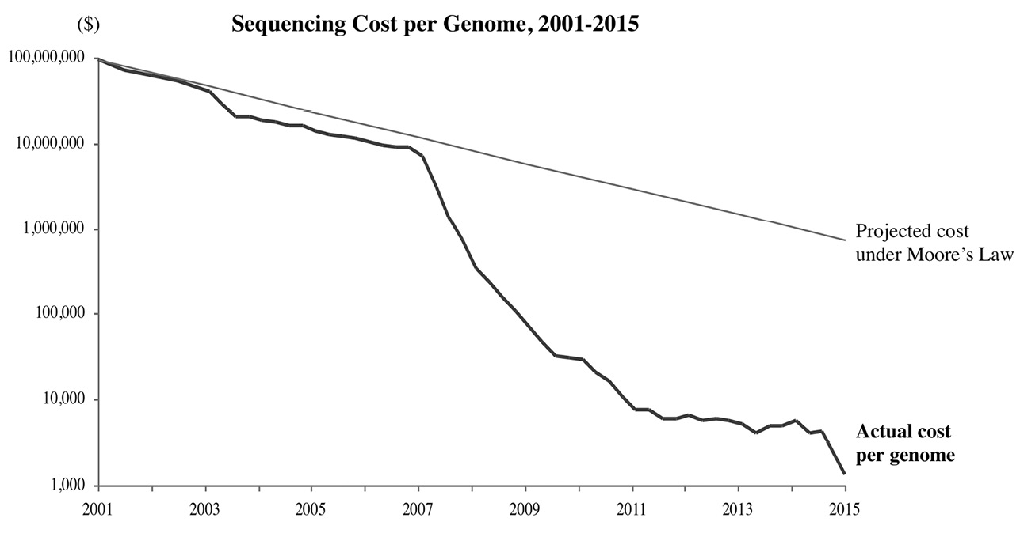
Figure 5-3. Genome sequencing costs are falling faster than Moore’s Law.
Source: Kris Wetterstrand (2015). “DNA Sequencing Costs: Data from the NHGRI Genome Sequencing Program (GSP).” National Human Genome Research Institute. Retrieved from www.genome.gov/sequencingcosts.
- Description: Line graph titled "Sequencing Cost per Genome, 2001-2015". The vertical y-axis displays costs, from $1000 to $100,000,000. The horizontal x-axis displays years, from 2001 to 2015. There are two lines: one for the Projected cost under Moore's law, and one for the Actual cost per genome. From 2001-2007, the Projected cost and actual cost drop at the same rate, falling from $100,000,000 to $10,000,000. From 2007-2015, the Projected cost line falls from $10,000,000 to $1,000,000. The Actual cost line drops sharply between 2007 and 2011, falling from $10,000,000 to $10,000. From 2011 to late 2014, it remains around $10,000, then drops sharply again in 2015, to $1,000.

